

Guidelines for Registration at the University of Leeds

2017/18
Year One Students

Online Registration

Online Registration is a 7 step process – you must complete all 7 steps in order to be a registered student of the University of Leeds.

To simplify the process, please follow the instructions below, paying particular attention to the yellow text boxes.

First, log in to Minerva (http://minerva.leeds.ac.uk). You will need to follow the link to collect your username and password from the homepage.

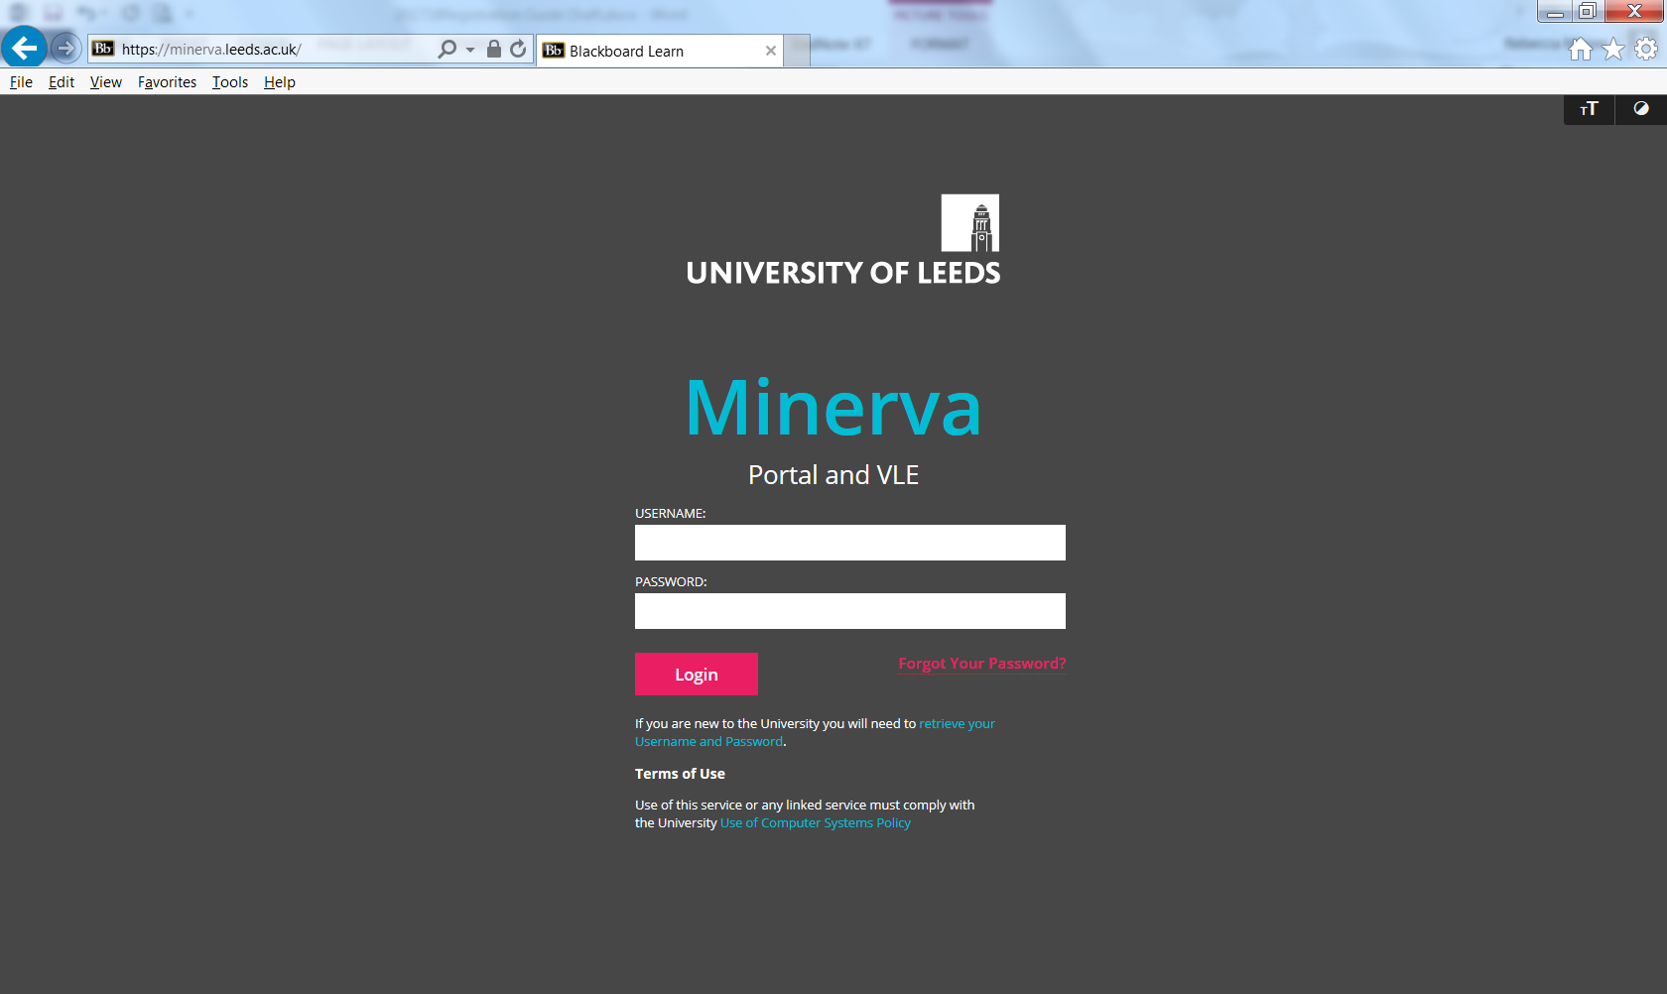
You need to find out your username and password. Click the link ‘retrieve your Username and Password’ and follow the steps. You will need your Leeds student ID and your date of birth.

You will be taken to the page shown below. Enter your Leeds student ID and your date of birth to get your username and password.

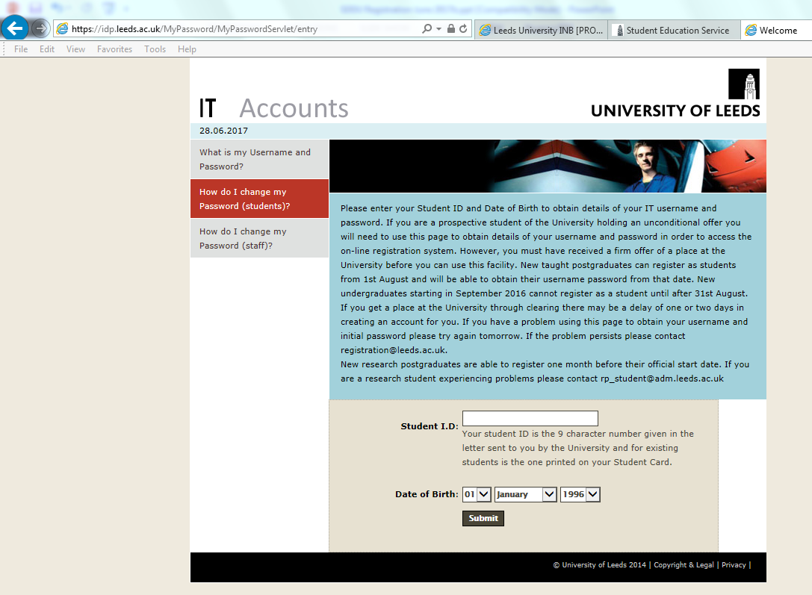
Your Leeds student ID is a nine figure number. You will be given this information.
Log in to Minerva (http://minerva.leeds.ac.uk). Once logged in, click the Student Services icon on the top bar:

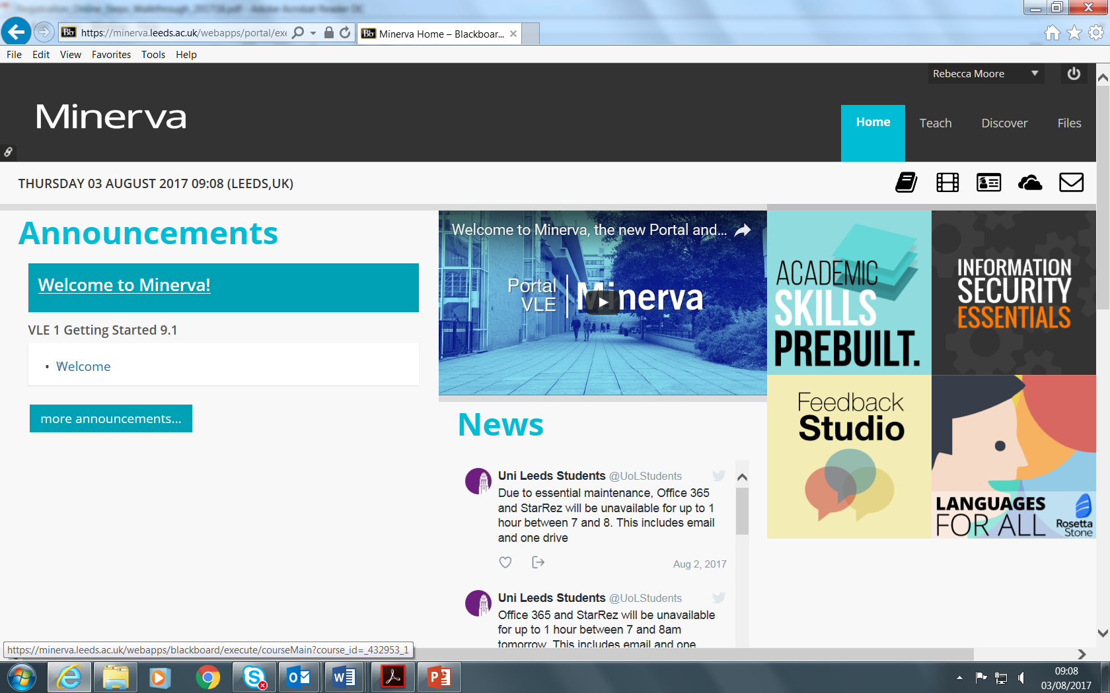

The Student Services icon will take you to the Student Services pages. Choose Registration from the list of options.

Click ‘Registration’

Then, on the Registration Checklist page, click Personal Details 1 to begin

Click ‘Personal Details 1’ to begin online registration

Step 1: Personal details 1

This must match the names in the boxes above. It is the name that will be on your degree certificate
Enter any changes needed in the boxes here
You do not need to do anything here
You do not need to do anything here
Click ‘Continue’ to save and move on to the next step
Step 2: Personal Details 2
You can tick No Comment here if you prefer
You can tick No Comment here if you are not sure
You do not need to read this section
Click Continue
Step 3: Addresses, telephone numbers and emergency contact details

This section should already be filled in with the Joint School address. Do not change it.
Click Continue
This section should already be filled in with the Joint School address. Do not change it.
Click Continue

This section should be filled in already with the Joint School address.
Click Continue

Contact details summary page
After all three address types have been confirmed, you will be presented with a summary of the information and required to confirm that all the addresses held are correct
Check the details are correct
Tick this box
Click Continue
Step 4: Sports membership
You do not have to read this – go to the bottom of the page
Tick this box only
Click Continue
Step 5: Programme of Study Details
This section should be completed already with your Programme details
Tick this box
Click Continue
Step 6: Fee Payment Arrangements
You do not need to read this – go to the bottom of the page
Click Continue
Step 7: Declaration Statement
Check all this information carefully
Tick this box if all the information is correct
Click 'Save and Continue to next step'

Final confirmation (registration certificate) page
The “print registration certificate” button will open the standard print process:
Print or download and save your Registration Certificate.
Ignore these sections
Ignore these sections

You have now completed online registration!

You just need to attend an ID check (if not done already) to finish registering as a student at the University of Leeds.

Your timetable tells you when and where to go for the ID check. You will need to take a form of ID which includes a photograph, for example a passport.

